Screenshots of the Simulator using Regions
The following screenshots show the simulator simulating the microwave oven example as available in the examples folder. States marked in red are active at the moment. Transitions marked in blue can be triggered from the active states. The output window shows the executed code (i.e. the entry/do/exit code you added to the state diagram). The simulator has to be called the following way (if in the microwave_ea9_using_regions_c folder):
java -jar ../../bin/codegen.jar -E -p EA -t "Model:implementation:oven" -o oven oven.xml

After startup and reset of the simulation
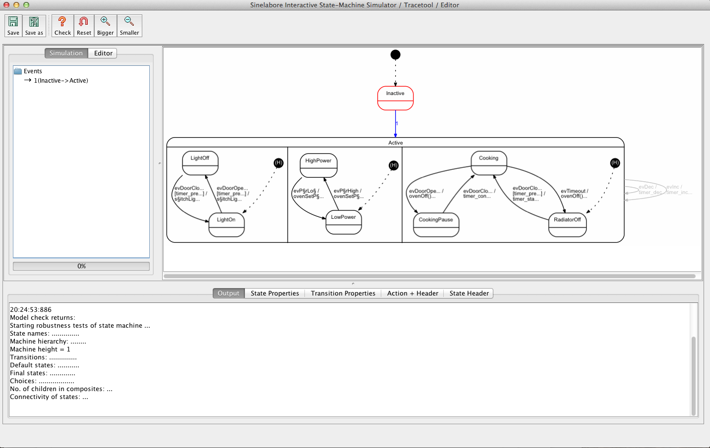

After some time of cooking and then opening the door (pause)
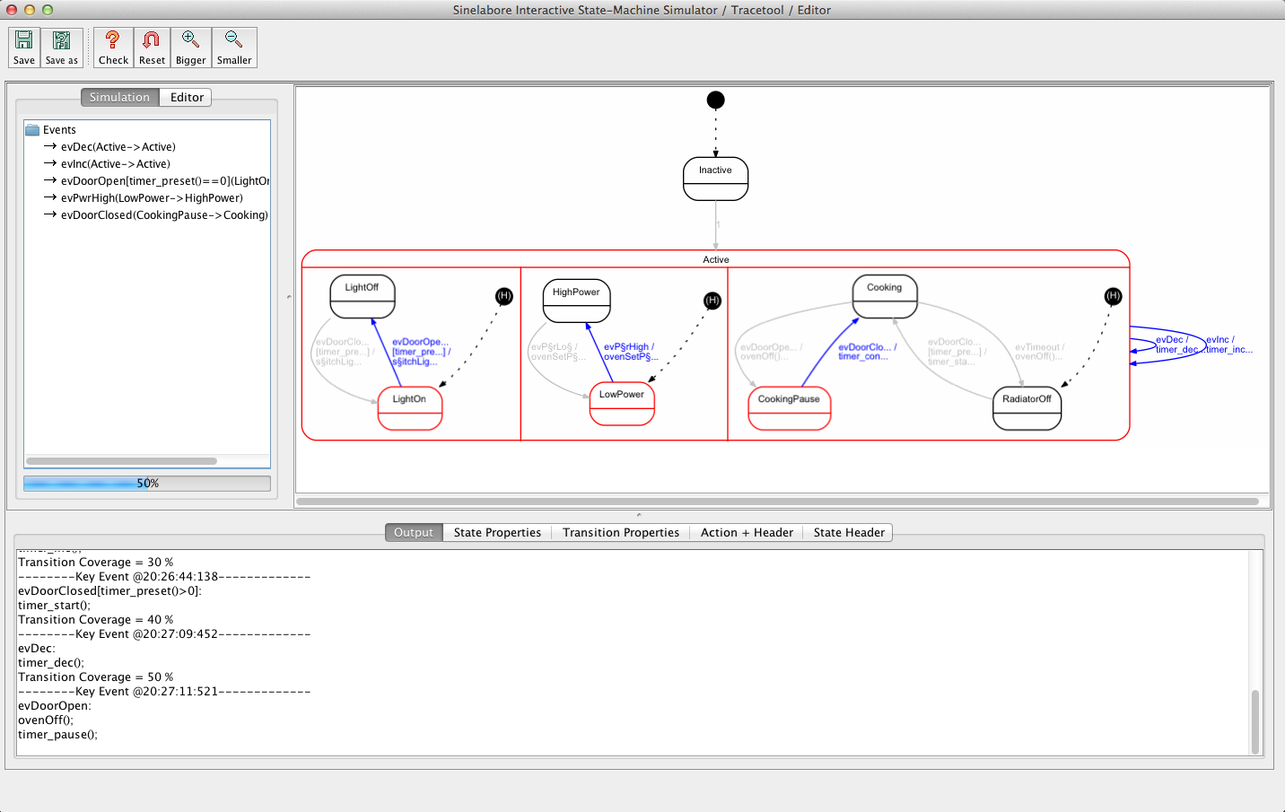

After oven has counted down to zero and waiting the cook to open the door.
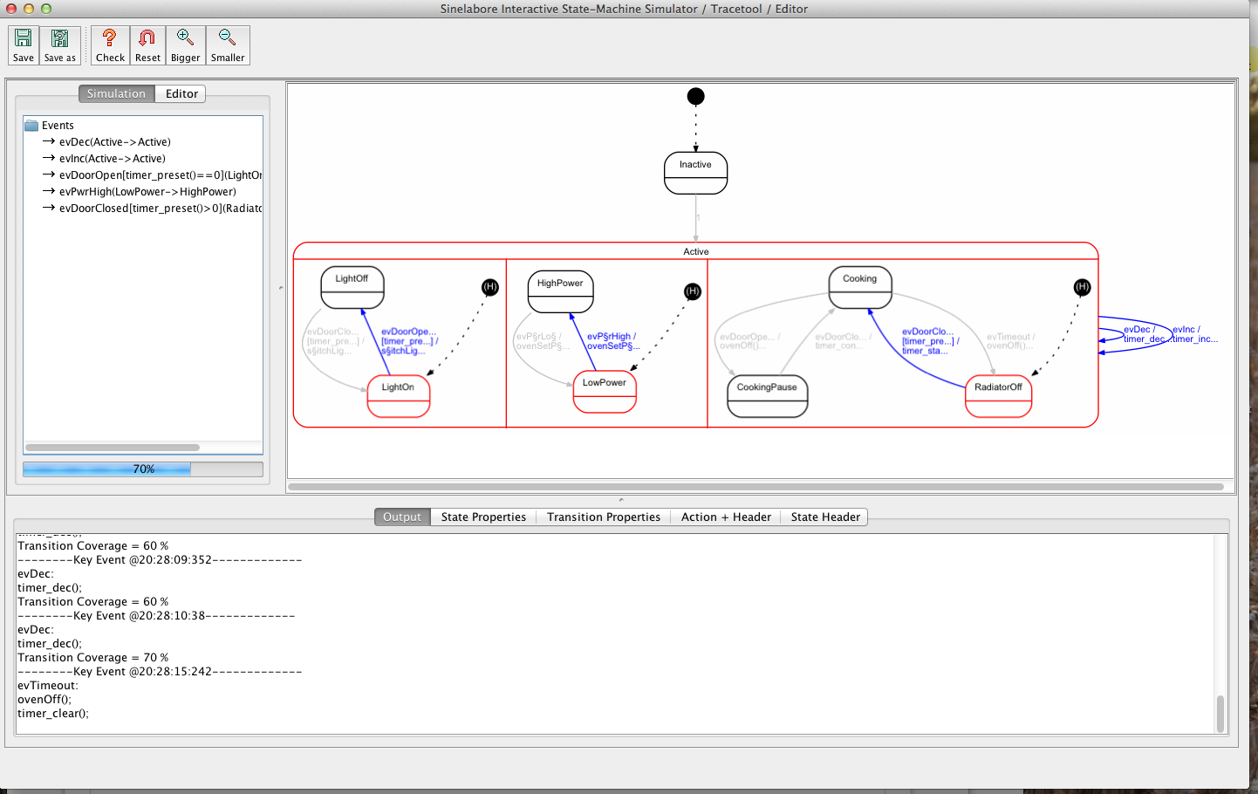

A demo of the code generator is available for download. Give it a try!

