Activity diagram generation from UModel
With this new version 3.6.2 it is now possible to generate code from activity diagrams created with UModel. UModel has support for the basic activity elements such as actions, init - and final nodes.
The microwave oven model microwave_handbook_umodel was extended to show how to use activity diagrams together with state machines in UModel. The example uses a selftest function called at initialisation of the state machine. If the selftest fails the machine enters an error state. The following figures show the extended oven model and a very simple selftest activity diagram.
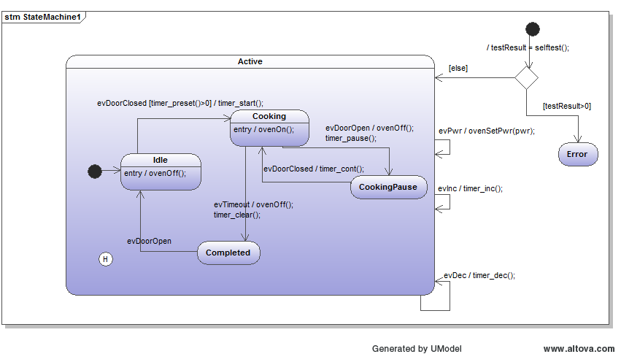
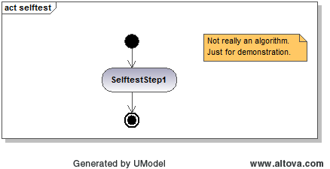
Download the latest version and give it a try. Activity modelling is a very useful extension to state machine modelling!
Have fun!

